Small Basic Tasks

Create a Hello World application

1: Can you make it write your name?

2: Change the colour.

Finished? Try a different colour and have it write your name.

3: Getting the text window to read!

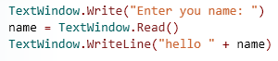
Finished? Get the program to ask you the name of a firend and Writeline that out as well.

4: Numbers

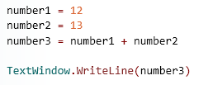
This is adding up two numbers.

Finished?
Can you get it to ask you for those two numbers in the code?

It might look something like this:

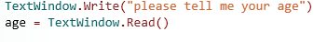
Now it needs another writleline if you can’t remember look at the name example : Task 3

