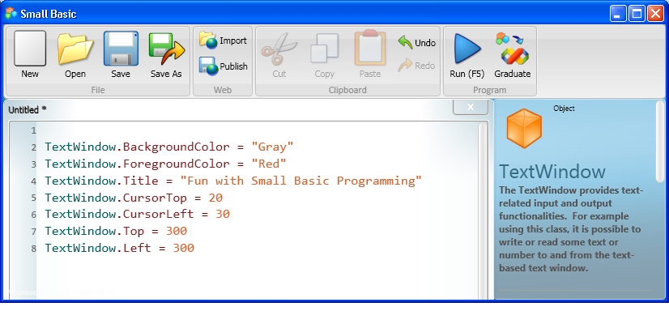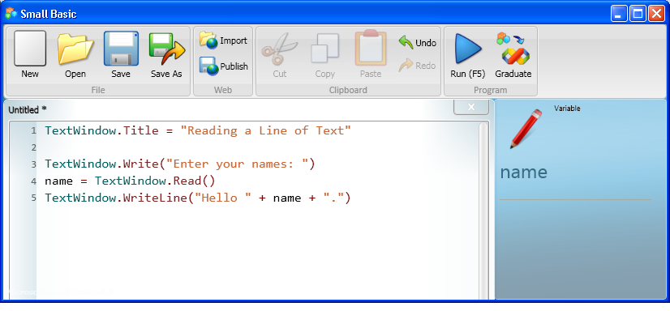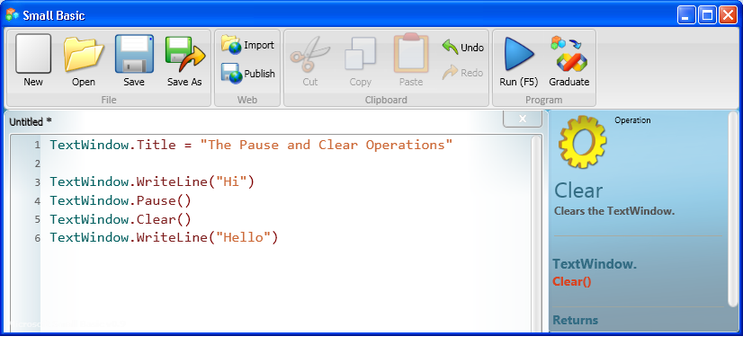

* Set the top position of the text window to 100, and set its left position to 200.
* Write a statement that makes “Small Basic Programming” appear in the title bar of the text window.
* Set the top position of the cursor to 10 and left position to 20.
* Set the foreground color of the text to yellow.
* Display the sentence, “Welcome to the world of Small Basic programming.”